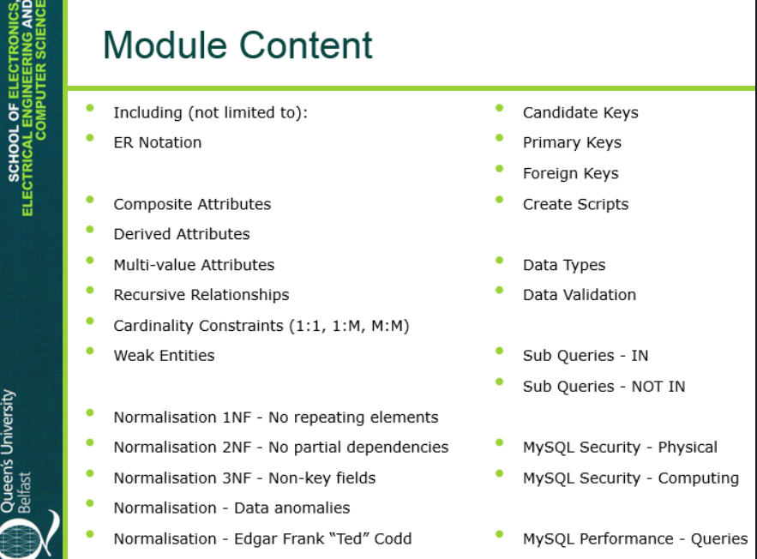

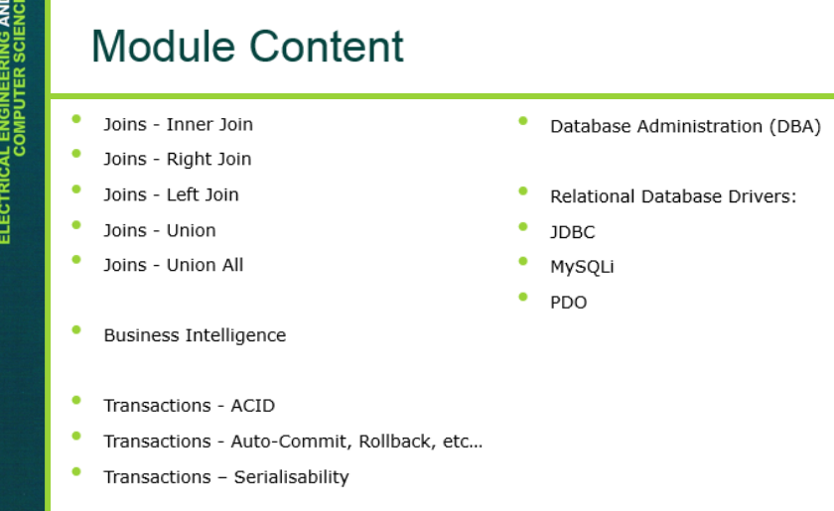

Do the labs again and look at queries that involve using functions in joins –

Look at normalisation – data anomalies and ted codd

Watch the DBA lecture – and the Relational database drivers lecture – mostly 2nd half

Review Data types/data validation and performance/security-

Now I will look at the